Aim:
MODULE 5
Association Rule Mining – Apriori Algorithm and FP growth

To write a python program to find the rules that describe associations by using Apriori

algorithm between different products in the dataset and a python program to find the rules that describe associations by using FP-Growth algorithm between different products in the dataset.

APRIORI ALGORITHM
Procedure: Step 1:
Data Preparation Prepare your transactional dataset where each transaction contains a set of items. Ensure that your dataset is in a suitable format for association rule mining.

Step 2:
Initialization Set a minimum support threshold (min_support) and a minimum confidence threshold (min_confidence) to identify frequent itemsets and generate association rules. Optionally, set other parameters such as the maximum number of items in a frequent itemset.

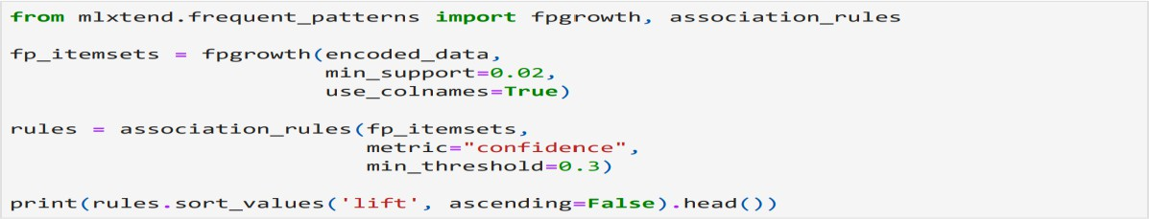
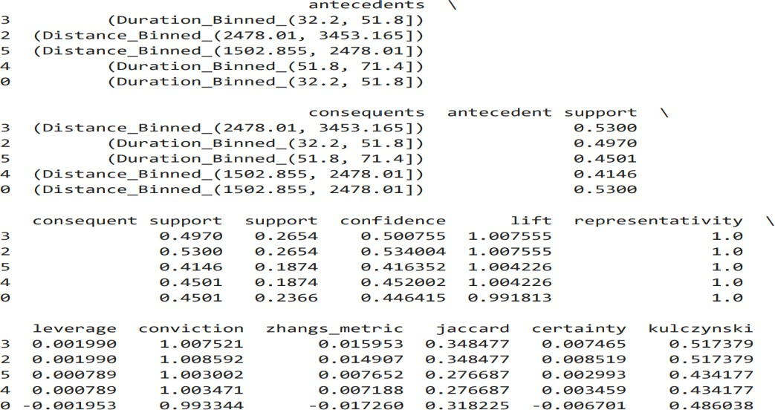

Fig 5.1 Min Confidence and Min Support

Step 3:
Generate Frequent Itemsets Start by finding all frequent 1-itemsets (single items) in the
dataset by counting the occurrences of each item. Prune infrequent itemsets (those with support below min_support) from the candidate itemsets. For larger itemsets (k+1), generate candidate itemsets by joining frequent itemsets of size k and prune those that contain infrequent subsets.

Step 4:
Calculate Support for Candidate Itemsets Count the occurrences of each candidate itemset in the dataset and calculate its support (the proportion of transactions containing the itemset).

Step 5:
Prune Infrequent Itemsets Remove candidate itemsets with support below min_support.

Step 6:
Generate Association Rules From the frequent itemsets, generate association rules that satisfy the minimum confidence threshold (min_confidence). An association rule is of the form A -> B, where A and B are itemsets, and the confidence of the rule is the proportion of transactions containing A that also contain B.

Step 7:
Calculate the parameters for all possible combination of items Three major measures commonly used to validate association rules are:
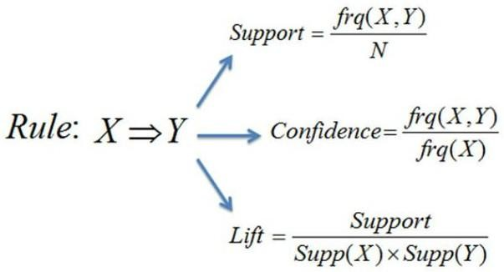

Support:
Support measures the frequency of occurrence of an itemset in the dataset. It indicates how often the itemset appears in the transactions.
The support of an itemset {X} is calculated as the proportion of transactions in the dataset that contain the itemset {X}.
Mathematically, support(X) = frequency({X}) / total_transactions.

High support values indicate that the itemset occurs frequently in the dataset and is more significant.

Confidence:
Confidence measures the reliability of an association rule. It indicates the likelihood that the consequent (Y) occurs given the antecedent (X). The confidence of a rule X → Y is calculated as the support of the itemset {X, Y} divided by the support of the itemset {X}.
Mathematically, confidence(X → Y) = support(X ∪ Y) / support(X).
High confidence values indicate a strong association between the antecedent and consequent of the rule.

Lift:
Lift measures the strength of the association between the antecedent and consequent of a rule relative to their individual support levels. Lift(X → Y) is calculated as the ratio of the confidence of the rule X → Y to the support of the consequent Y.
Mathematically, lift(X → Y) = confidence(X → Y) / support(Y).
Lift values greater than 1 indicate that the occurrence of the antecedent and consequent together is more likely than would be expected if they were independent.
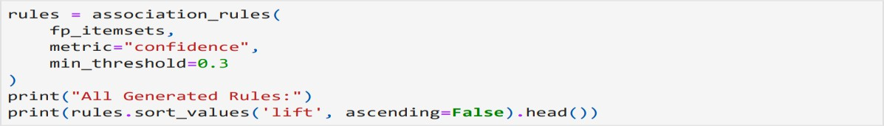
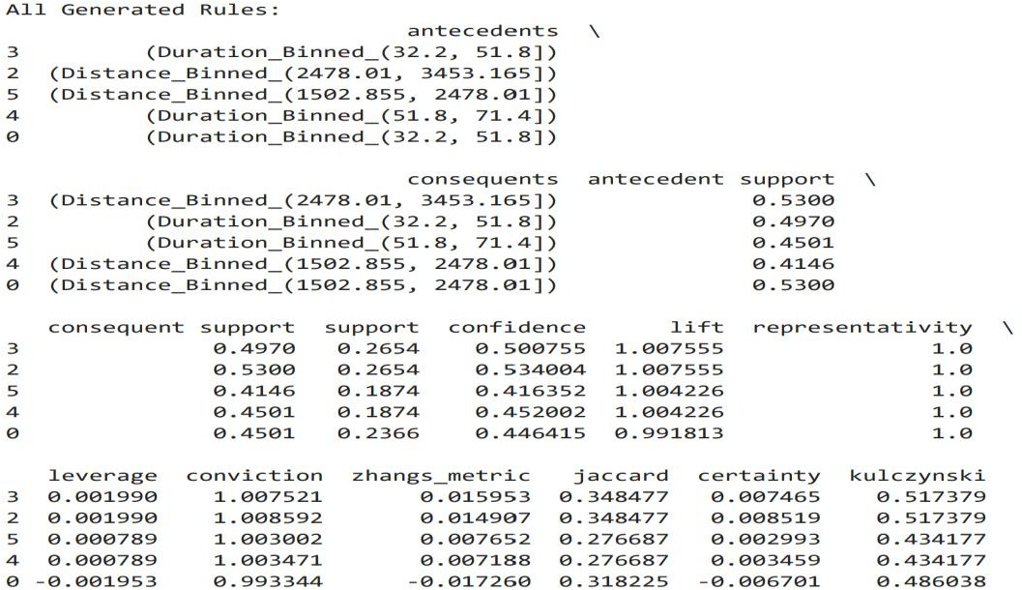

Fig 5.2 Support , Confident , Lift values

Step 8: Repeat (Optional)
Optionally, repeat the process with different support and confidence thresholds to find different sets of association rules. Experiment with different parameters to explore the trade- off between the number of rules generated and their quality.
Step 9: Interpretation and Analysis
Interpret the generated association rules to understand the relationships between items in your dataset. Analyze the results to gain insights into customer behaviour, market basket analysis, or any other relevant domain specific applications.

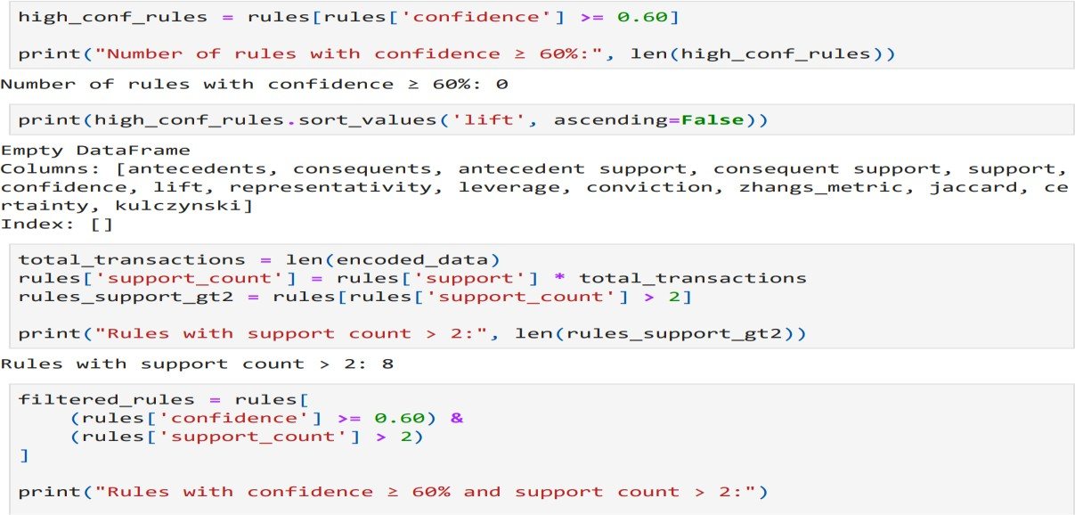
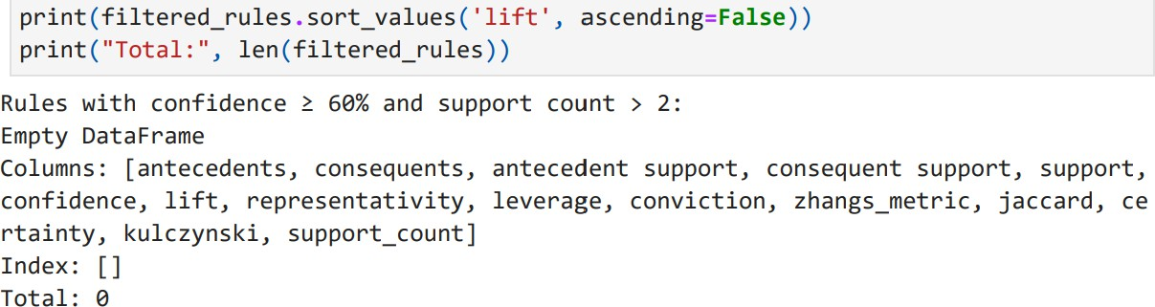

Fig 5.3 Analysis and Behaviour Rules

FP GROWTH
Procedure:
Step 1: Data Preparation
Prepare your transactional dataset where each transaction contains a set of items. Ensure that your dataset is in a suitable format for association rule mining.

Step 2: Initialization
Set a minimum support threshold (min_support) and a minimum confidence threshold (min_confidence) to identify frequent itemsets and generate association rules. Optionally, set other parameters such as the maximum number of items in a frequent itemset.
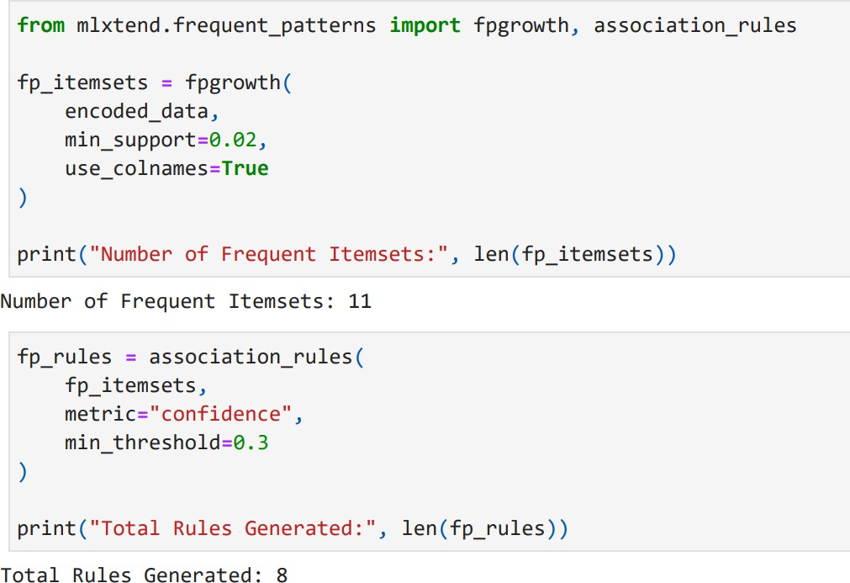

Fig 5.4 Min Support and Min Confidence values

Step 3: Creating the FP-Tree:
First, the algorithm scans the dataset to determine the frequency of each item (individual products in a market basket analysis, for example). It then constructs a data structure called the FP-tree (Frequent Pattern tree). The FP-tree is a compact representation of the dataset that encodes frequency information along with the relationships between items.
Step 3.1: Create a class for the FP-tree node: Define a class to represent the nodes of the FP-tree. Each node should contain information about the item it represents, its frequency count, and its children.
Step 3.2: Scan the dataset and count item frequencies: Iterate through the dataset to count the frequency of each item.

Step 3.3: Construct the FP-tree: Based on the frequency information obtained in the previous step, construct the FP-tree by inserting transactions into the tree.
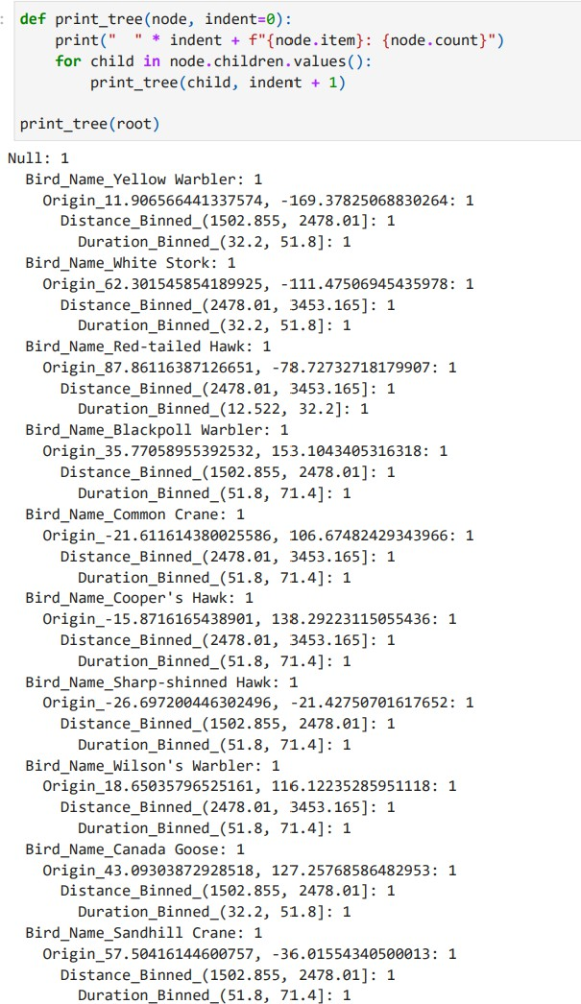

Fig 5.5 FP- Tree Visualization

Step 4: Building the Conditional FP-Tree:
After constructing the FP-tree, the algorithm extracts frequent itemsets from it. It does this by recursively mining the FP-tree to find frequent itemsets. At each step, it examines the conditional pattern base, which is a subtree of the FP-tree containing only the items that are

frequent with respect to a given item. It then constructs a conditional FP-tree for each frequent item by removing the infrequent items and their associated branches from the FP-tree.

Step 5: Extracting Frequent Itemsets:
Finally, the algorithm recursively repeats Step 3 for each conditional FP-tree until no more frequent itemsets can be found. It then combines the frequent itemsets obtained from each conditional FP-tree to produce the final set of frequent itemsets for the entire dataset.

Step 6: Generate Association Rules
From the frequent itemsets, generate association rules that satisfy the minimum confidence threshold (min_confidence).
An association rule is of the form A -> B, where A and B are itemsets, and the confidence of the rule is the proportion of transactions containing A that also contain B.


Step 7: Calculate the parameters for all possible combination of items Three major measures commonly used to validate association rules are: Support:
Support measures the frequency of occurrence of an itemset in the dataset. It indicates how often the itemset appears in the transactions.
The support of an itemset {X} is calculated as the proportion of transactions in the dataset that contain the itemset {X}.
Mathematically, support(X) = frequency({X}) / total_transactions.
High support values indicate that the itemset occurs frequently in the dataset and is more significant.

Confidence:
Confidence measures the reliability of an association rule. It indicates the likelihood that the consequent (Y) occurs given the antecedent (X).The confidence of a rule X → Y is calculated as the support of the itemset {X, Y} divided by the support of the itemset {X}.
Mathematically, confidence(X → Y) = support(X ∪ Y) / support(X).

High confidence values indicate a strong association between the antecedent and consequent of the rule.

Lift:
Lift measures the strength of the association between the antecedent and consequent of a rule relative to their individual support levels.
Lift(X → Y) is calculated as the ratio of the confidence of the rule X → Y to the support of the consequent Y.
Mathematically, lift(X → Y) = confidence(X → Y) / support(Y).
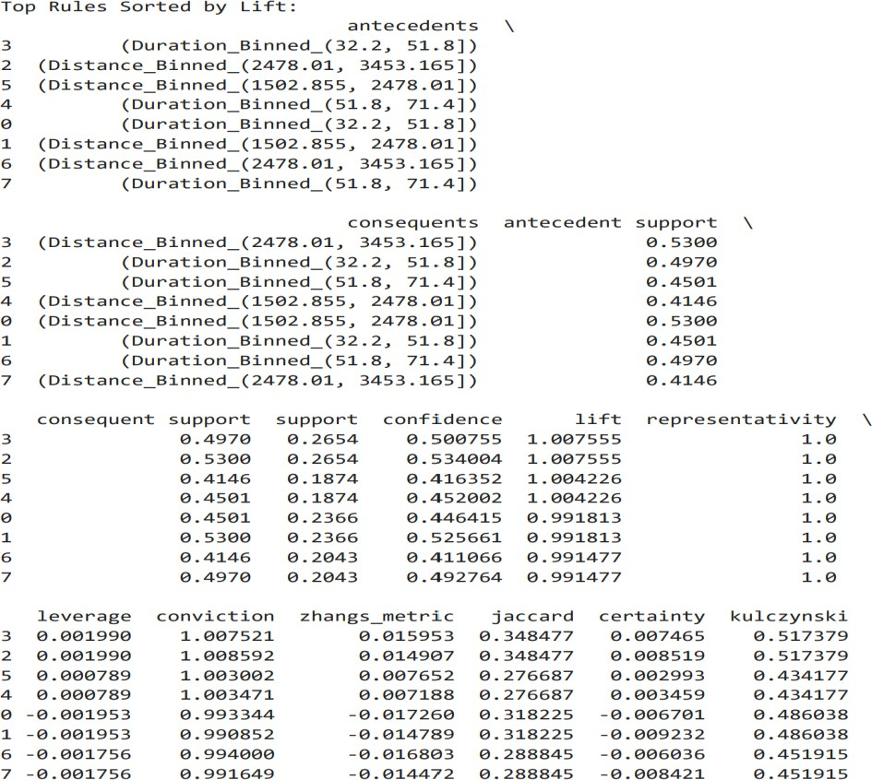

Fig 5.6 Support , Confidence , Lift Rule

Step 8:
Repeat (Optional) Optionally, repeat the process with different support and confidence
thresholds to find different sets of association rules. Experiment with different parameters to explore the trade-off between the number of rules generated and their quality.

Step 9:

Interpretation and Analysis Interpret the generated association rules to understand the relationships between items in your dataset. Analyze the results to gain insights into customer
behavior, market basket analysis, or any other relevant domain specific applications.

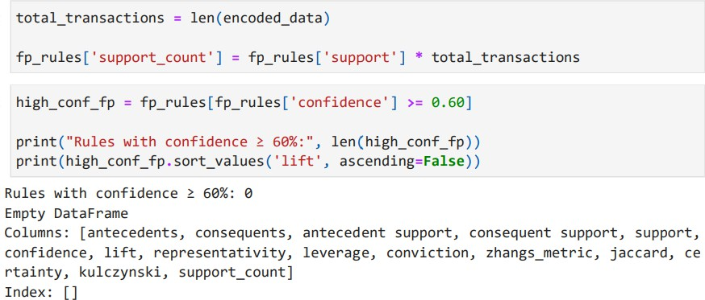

Fig 5.7 Rules with confidence value greater than 60%

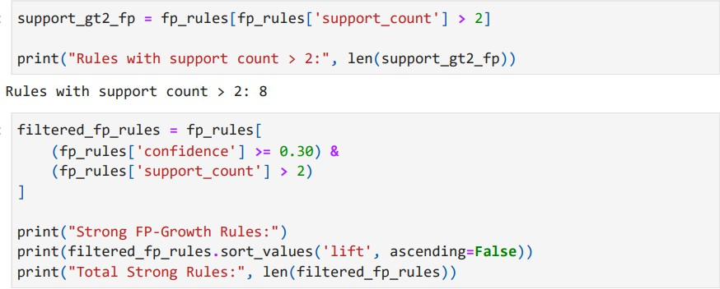

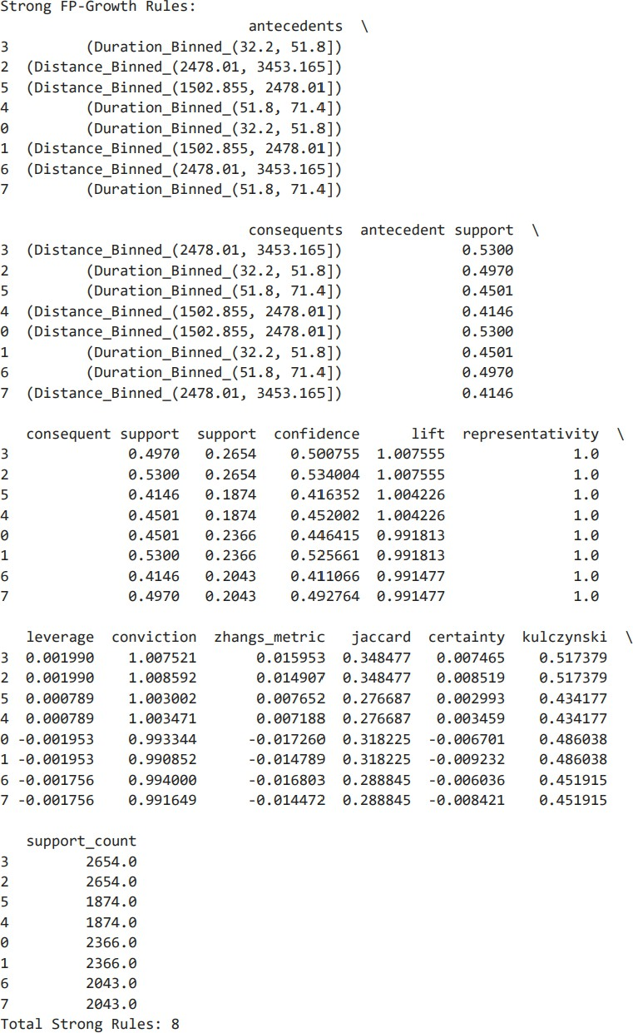

Fig 5.8 F P- Growth Rules
Problem Statement:
Statement 1: Approri algorithm
Bird Migration Association Rule Mining Using Apriori
Write a python program to find association rules using the Apriori algorithm to understand the relationships between bird species, their origins, flight distances, and flight durations given the Bird Migration dataset.
- Extract a subset of the data containing Bird_Name, Origin, Flight_Distance_km, and Flight_Duration_hours.

- Preprocess the data by discretizing the continuous variables (Flight_Distance_km and Flight_Duration_hours) into 4 equal bins each, and apply one-hot encoding to the final selected features.
- Generate frequent itemsets using the Apriori algorithm with a min_support of 0.02.
- Generate the initial association rules with a min_threshold (confidence) of 0.3.
- Filter the rules to find the strongest associations with confidence >= 0.60 and support_count
> 2, and display the top rules sorted by descending Lift.
- Visualize the Apriori association rules by creating a scatter plot of Support vs. Confidence

Statement 2: FP growth
Bird Migration Association Rule Mining Using FP-Growth
Write a python program to find association rules using the FP-Growth algorithm to understand the relationships between bird species, their origins, flight distances, and flight durations given the Bird Migration dataset.
- Extract a subset of the data containing Bird_Name, Origin, Flight_Distance_km, and Flight_Duration_hours.
- Preprocess the data by discretizing the continuous variables (Flight_Distance_km and Flight_Duration_hours) into 4 equal bins each, and apply one-hot encoding to the final selected features.
- Generate frequent itemsets using the FP-Growth algorithm with a min_support of 0.02.
- Generate the initial association rules with a min_threshold (confidence) of 0.3.
- Filter the FP-Growth rules to identify strong and meaningful associations (e.g., confidence
>= 0.60 and support_count > 2), and display the top rules sorted by descending Lift.
- Visualize the FP-Growth association rules by creating a scatter plot of Support vs. Confidence.

Result:
Thus, a python program to find the rules that describe associations by using Apriori algorithm between different products in the dataset was performed.

